**CS590BD**

**Big Data Analytics and Apps**

**First Increment**

**Team:** Tunuguntla, Jeevana

Bathina, L V Sandeep

Marikanti, Goutham

Beeravalli, Ramakrishna Reddy

**Project goal and Objectives**

* **Motivation**: Gaming is the new face of entertainment. Upon learning that this form of entertainment also adds to the development of knowledge and intelligence of end user, we have chosen this work on this project. On an elaborated view, analysis of scores yielded from the game would be useful in assessing the intelligence level of individuals.
* **Significance**: Using generated data from game application we do analyze Data, based on analysis we can prepare a statistics of the user in his/her desired field. This type of analysis not only helps a particular user but also help many organizations, health organization and educational institution to asses a student or employee field of interest and to determine their capability.
* **Objectives:** our main goal in this project is to collect the data (i.e.) text file from an android device, this file mainly contains pattern in which a user is playing. Then we need to push this file to the hadoop file system and using an algorithm we analyze this data to generate report and also we will provide recommendations to user to improvise them in their field of interest.
* **System features:**

**OS:** windows/linux

**Ram:** 4 GB or above

Android device version: at least 4.3

**IDE**: Eclipse ADT (to run android application) , eclipse kelper/juno(to run java application)

**Devices:** Sensor tags, android mobile having Bluetooth above 4.2.

**Activity Recognition scenario and data collection**

* **Devices/ Sensors**: CC2541 Sensor Tag  Development Kit, Computer with a minimum of i7 processor and 4gb Ram
* **Data Collection**: Data that would be generated from the game is in .txt file format and it is collected and stored in tables which we have created in HBASE.
* **Motion/activity Model**:

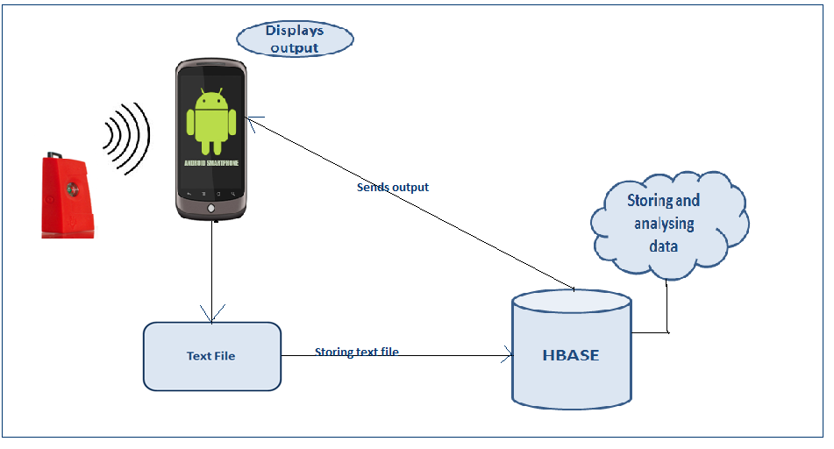

* **Analytical tasks**: The data shall be assessed for adaptive level information, and the performance of the gamer would be analysed based on the score he/she scores.
* **Design of mobile client :**

**Features**: android device version-4.4.2

**Styles and GUI:**

1. In order to develop the project, we got the open source android game from the internet. Here, we will make some changes in the game source code according to our project interest.

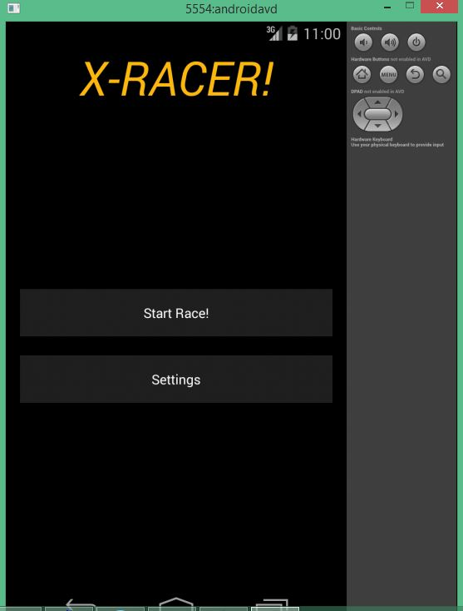

1. So here, we will capture the objects according to the questions we fire. So based on that we will retrieve the report and analyze them accordingly.

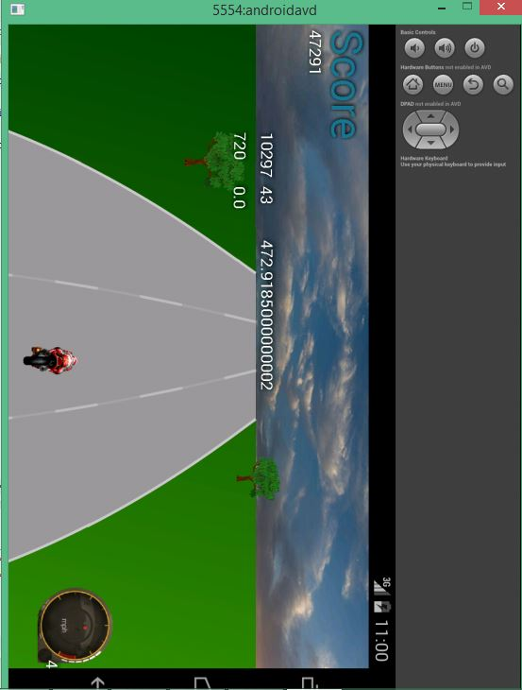

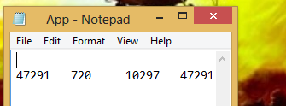

1. The analyzed part here is kept in the HBASE system tables in the form of rows and columns

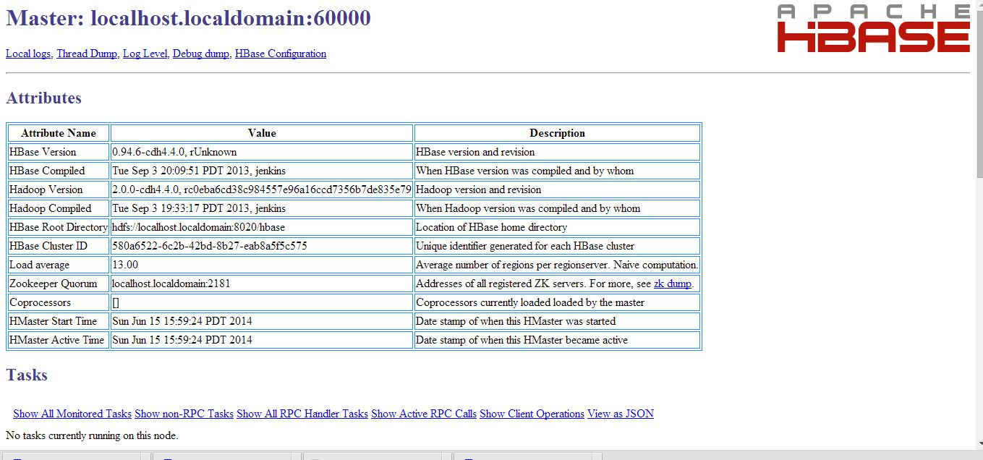

**Technologies**: Java , HBASE

* **Project Planning with Scrumdo:**

[https://www.scrumdo.com/organization/cs590bd/dashboard](%09https://www.scrumdo.com/organization/cs590bd/dashboard)

* **Related work :**

<http://www.mel.nist.gov/msidlibrary/doc/serious_games02.pdf>

<http://newsroom.ucla.edu/releases/is-technology-producing-a-decline-79127>

[http://www.techradar.com/us/news/gaming/consoles/why-virtual-reality-gaming-is-the-future-of- playstation-4-1217071](http://www.techradar.com/us/news/gaming/consoles/why-virtual-reality-gaming-is-the-future-of-playstation-4-1217071)

.<http://www.lcc.uma.es/~ccottap/papers/lara13review.pdf>

* **Bibliography**

<http://www.edureka.in/>

<http://developer.android.com/training/basics/actionbar/index.html>

<http://efytimes.com/e1/fullnews.asp?edid=134678>